I am confident in the water and understand that I will always be required to wear a buoyancy aid while near the water. I also understand that trainees sail at their own risk and Himley Hall Sailing Club cannot be held responsible for their personal property or safety. |  |  |  |  | Himley Hall  Sail Training Centre |  | LEVEL 1 & 2  DINGHY SAILING COURSES 2018 | 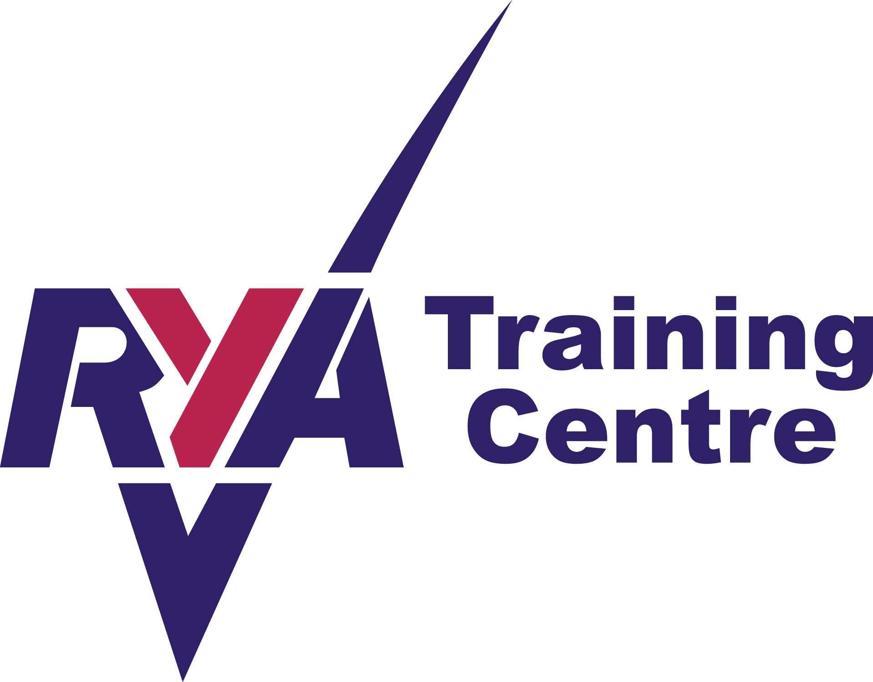
I agree to abide by any rules of conditions imposed by the instructors or safety staff.
I understand that I must declare if I am suffering from or liable to affected by any complaint that may render me unwell or perhaps require medical attention e.g. epilepsy, diabetes, heart disease etc. |  |  |  | Autumn | Level 1 | 7th September (evening) + 8th/9th September
 |  |  |  |  | Level 2 | 15th/16th September
Have you any relevant medical conditions? |  | Yes / No |  | Evening Sessions 6:30-8:30pm Saturday/Sunday Sessions 9:30am-4:00pm
If yes, please give details.
They will treated as confidential and only released to relevant training team members
Next of Kin (for emergencies): |  |  |  | 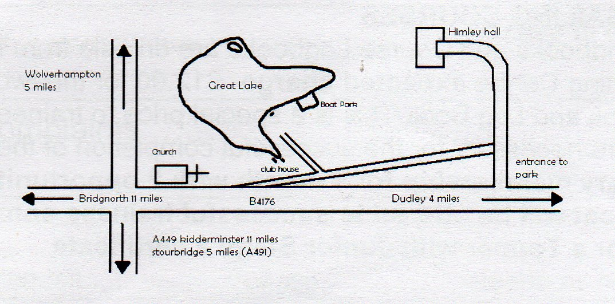  Himley Hall Sailing Club  Himley Hall and Park  Himley  Dudley  DY3 4DF
Next of Kin Telephone no:
Trainee’s Name:
Address:
Post Code:
Telephone no:
Email address:
Signed
(a parent or guardian should sign for any trainee under the age of 18)
Date
Where did you hear about our training courses:
 |  |  |  | www.himleyhallsc.org.uk

Training Information  Himley Hall Sail Training Centre is a Royal Yachting Association (RYA) recognised training centre. Our senior instructors and dinghy instructors are fully qualified RYA trainers and together with our assistant instructors and safety boat operators are trained First Aiders and have CRB/DBS clearance. To keep training costs to a minimum, everyone involved with our training centre is a volunteer who does not get paid for their work.  We currently use Wayfarers, Wanderers, Bytes, Toppers, a Laser Pico, 420, RS Feva & a Laser 13 for training purposes but we are continually improving our training fleet and these dinghies may change at any time.  All course take place over the course of a weekend (see page 1 for dates and times) and are booked on a first come first served basis. It may be possible to take either a Level 1 or Level 2 course in isolation if sufficient spaces are available.  Normally, the minimum age for an adult course is 12 but a younger child may be considered if they have suitable experience. We adhere to the child protection guidelines laid down by the RYA and a parent or guardian is expected to be in attendance at all times when a child under the age of 16 is attending a course. Children under the age of 16 can attain a RYA stage 1, 2 or 3 certificate on the above dates.  Please bring a packed lunch. Hot drinks & bottled water are provided free of charge and chocolate bars & canned drinks are available in the clubhouse at a reasonable charge.  Trainees are expected to wear clothing suitable for the weather on the day and soft shoes that will not damage the dinghies. Please bring a towel and change of clothes in case of capsize (there will be a compulsory capsize drill during at some stage during the course). Changing facilities and showers are available.  Himley Hall Sailing Club cannot be held responsible for loss or damage to articles left on the premises.  One month’s temporary membership of Himley Hall Sailing Club, together with 2 opportunities to use a club boat, will be offered to successful trainees attaining an Adult Level 2 or Junior Stage 2 certificate. |  | To: Mrs Lucy Griffiths  Training Secretary  The Post House  Bridgnorth Road  Stourton  South Staffs  DY7 5BQ  Tel: 07968 252190  Email: lucygriffiths1112@gmail.com
 |  | I wish to apply for entry to the training course(s)
 |  | Level 1& 2 Summer:
 |  | Level 1 & 2 Autumn:
 |  | Course Fees for Level 1 & 2 are as follows
 |  | Adult (including non returnable deposit/booking fee of £20) | £140
 |  | Junior – Aged 16 years & under  (including non returnable deposit/booking fee of £20) | £130
 |  | If only one weekend of the course is taken the fee for each weekend is | £80
 |  | Junior Aged 16 years & under | £70
 |  | RYA Handbook & Logbook (needed to complete course) | £12
 |  | Details of Junior Stage 1,2 & 3 Courses are available on request
 |  | Members of HHSC receive a discount of £10 on each full course.
 |  | If you join the club after a course we will waive the usual £20 joining fee.
 |  | I enclose:
 |  | Non returnable deposit/booking fee (£20)
 |  | Full fee

