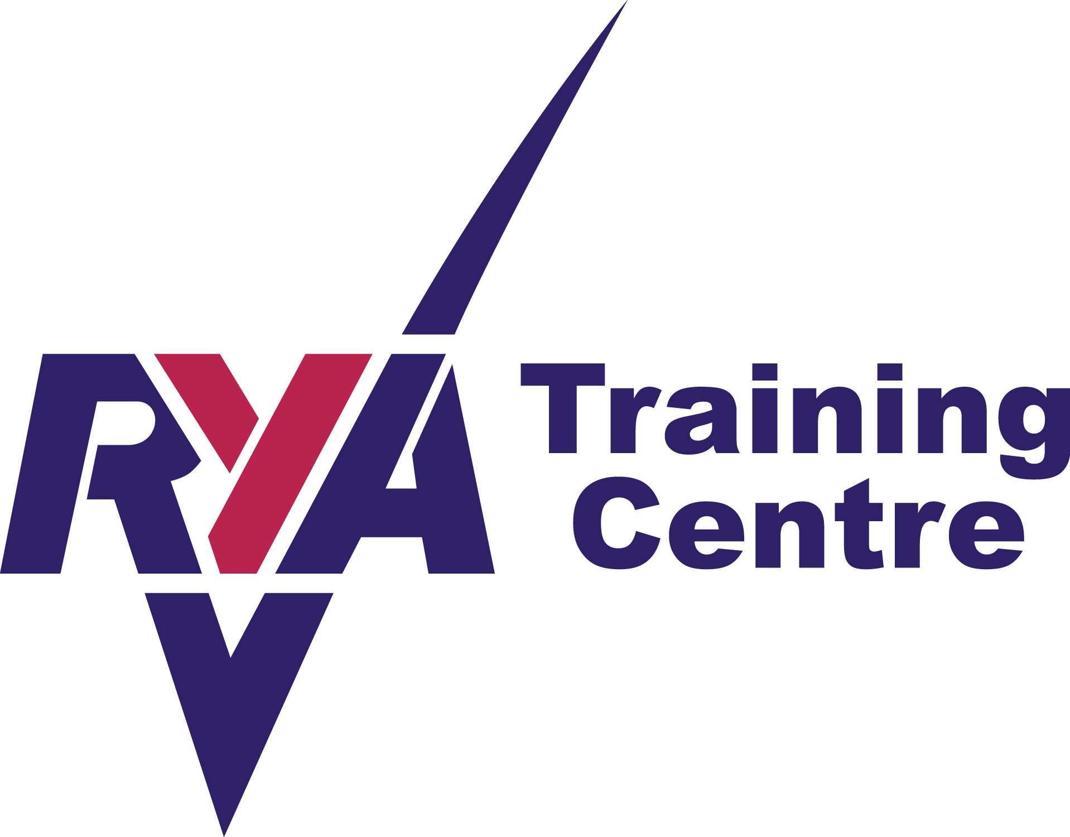
LEVEL 1 & 2
DINGHY SAILING COURSES 2023
Himley Hall Sail Training Centre

Introductory evening: 9th June 6.30pm-8.30pm
Level 1 10th /11th JuneTwo Full days 9.00-5.00 both days
Level 2 17/18th JuneTwo Full days 9.00-5.00 both days

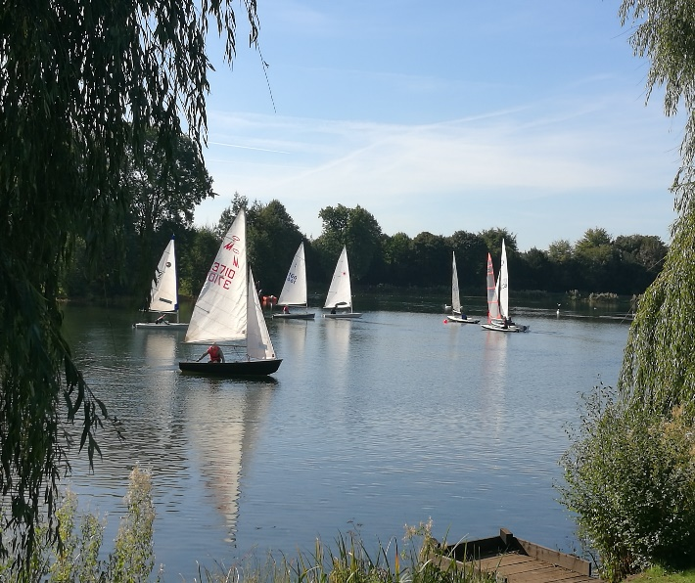
Location
Himley Hall Sailing Club
Himley Hall and Park
Himley
Dudley,DY3 4DF
Website: hhsc.weebly.com
Facebook: Himley Hall Sailing Club

Training Information

Himley Hall Sail Training Centre is a Royal Yachting Association (RYA) recognised training centre. Our senior instructors and dinghy instructors are fully qualified RYA trainers and together with our assistant instructors and safety boat operators are trained First Aiders and have CRB/DBS clearance. To keep training costs to a minimum, everyone involved with our training centre is an unpaid volunteer.

We currently use Wayfarers, Wanderers, Bytes, Toppers, Laser Picos, a 420, and an RS Feva for training purposes. All our training courses are booked on a first come first served basis. It may be possible to take either a Level 1 or Level 2 course in isolation if sufficient spaces are available, but priority will go to those booking the full course.

Normally, the minimum age for an adult course is 12 but exceptionally a younger child may be considered if he/she has suitable experience. We adhere to the RYA child protection guidelines and a parent or guardian is expected to be in attendance at all times when a child under the age of 16 is attending a course. Children under the age of 16 can attain a RYA stage 1, 2 or 3 certificate on the above dates.

Trainees need to wear clothing suitable for the weather on the day and soft shoes that will not damage the dinghies. Please bring a towel and change of clothes in case of capsize (there will be a compulsory capsize drill at some stage during the course). Changing facilities and showers are available. You will need to bring packed lunches
Three month’s temporary membership of Himley Hall Sailing Club, together with opportunities to use a club boat, will be offered to successful trainees attaining an Adult Level 2 or Junior Stage 2 certificate.

“I was really nervous, but the trainers quickly put me at my ease and it was a fantastic experience. I’d recommend it to anyone”
“We loved it and have now got our own boat! I never thought that would happen”
Trainees on recent courses

Please complete the form below (one for each person) & send it by post or email to:
Mrs Lucy Griffiths, Training Secretary, The Post House, Bridgnorth Road
Stourton, South Staffs, DY7 5BQ Tel: 07968 252190
Email: lucygriffiths1112@gmail.com
If emailing, please save it in Word if you can (a photo is acceptable but is often more difficult to read!)

I ……………………………………………… (your name)
- am confident in water and understand that I will always be required to wear a buoyancy aid while near the water.
- understand that trainees sail at their own risk and Himley Hall Sailing Club cannot be held responsible for their personal property or safety.
- agree to abide by any rules or conditions imposed by the instructors or safety staff.
- understand that I must declare if I am suffering from or liable to affected by any complaint that may render me unwell or perhaps require medical attention e.g. epilepsy, diabetes, heart disease etc.

Signature ………………………………………………….. Date,……………..
(a parent or guardian should sign for any trainee under the age of 18)

I wish to do the following course: (please tick/highlight which one)
Full course (both weekends) Adult £155….
Under 18 £140…….
(rates for single weekends are available by request but these are not always available)

Plus RYA Handbook & Logbook (needed to complete course) £12
Participation in the course includes 3 months membership, 3 complimentary boat hires, plus a discount if you join the club straight after the 3 month period is over

Do you have any relevant medical conditions? Yes/No
If yes, please give details …………………………………………………………………………………………………………
NB This will be treated as confidential and only released to relevant training team members

Your Address: …………………………………………………………………………………………
………………………………………………………...…Postcode………………………………….
Email address………………………………………….
Next of Kin (for emergencies): Name ……………………...………… Telephone no:……………

Courses can be bought vis the club shop (https://himley-hall-sailing-club.sumup.link/products) or by bank transfer (please email for the club’s bank details)

Please let me know when you have paid, as your place is then reserved.
We do not offer refunds if you cancel less than 6 weeks before the course; however, we will allocate you a place on the next course at the same price, even if there is a price increase

